The Aruco marker detection algorithm does the following steps to determine the aruco's quadrant.

1) Grab the current frame of the video stream

2) Use the aruco.detectMarkers method to get an array of the marker corner coordinates

3) Use the corners to calculate the midpoint of the aruco markers.

3a)

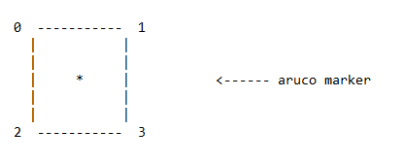

Calculate the midpoint (\*) (both x and y) between the 0 and 3 corners.

Calculate the midpoint (\*) (both x and y) between the 1 and 2 corners.

Average the two calculated midpoints to get a good approximation of the actual midpoint

4) Use the full dimensions of the frame to find the midpoint of the frame

4a)

midX = totalWidth / 2

midY = totalHeight / 2

5) Compare the midpoint of the aruco marker to midX and midY to figure out what quadrant the aruco marker is in

6) Relay the quadrant to other subsystems